ATTACHMENT-7

Testing of Indigenously Developed Flight Control Computers at TEKNOFEST Rocket Competition Finals

Contents
1. Main Purpose of Flight Control Computers 3
1.1. FCC’s Main Purpose and Duties 3
1.2. Definition of the Rocket Body-Fixed Coordinate System 3
2. Testing Indigenously Developed FCCs 4
2.1. Test Scenarios 5
2.1.1. SMT Scenario 6
2.1.2. SMT Implementation Plan 8
2.1.3. SFT Scenario 9
2.1.4. SFT Implementation Plan 11
2. Testing Requirements 12
2.2. Communication Requirements 12
2.3. Hardware Requirements 13
2.4. Electrical Requirements 14
3. Checksum and its Calculation 15
4. Sample Communication and Application 15
4.2. Sample Conversion from 4 Byte Array to FLOAT32 15
4.3. Sample Conversion from 4 Byte Array to FLOAT32 16

Main Purpose of Flight Control Computers
The Flight Control Computers (FCC) used in the TEKNOFEST Rocket Competition ensure that the rocket flies safely, while collecting and analysing the rocket flight data and activating the recovery system under the predetermined conditions, allowing the safe recovery of the rocket and its payload (the activation of hot/cold gas or mechanical separation system, and safe landing with a parachute).

FCC’s Main Purpose and Duties
During the flight of the rocket, the FCC carries out situational analyses for the collection of flight-related data from various sensors on the rocket, and makes flight-related decisions in accordance with the scenarios in the FCC Main Algorithm. The FCC fulfils its tasks in accordance with the process defined below:
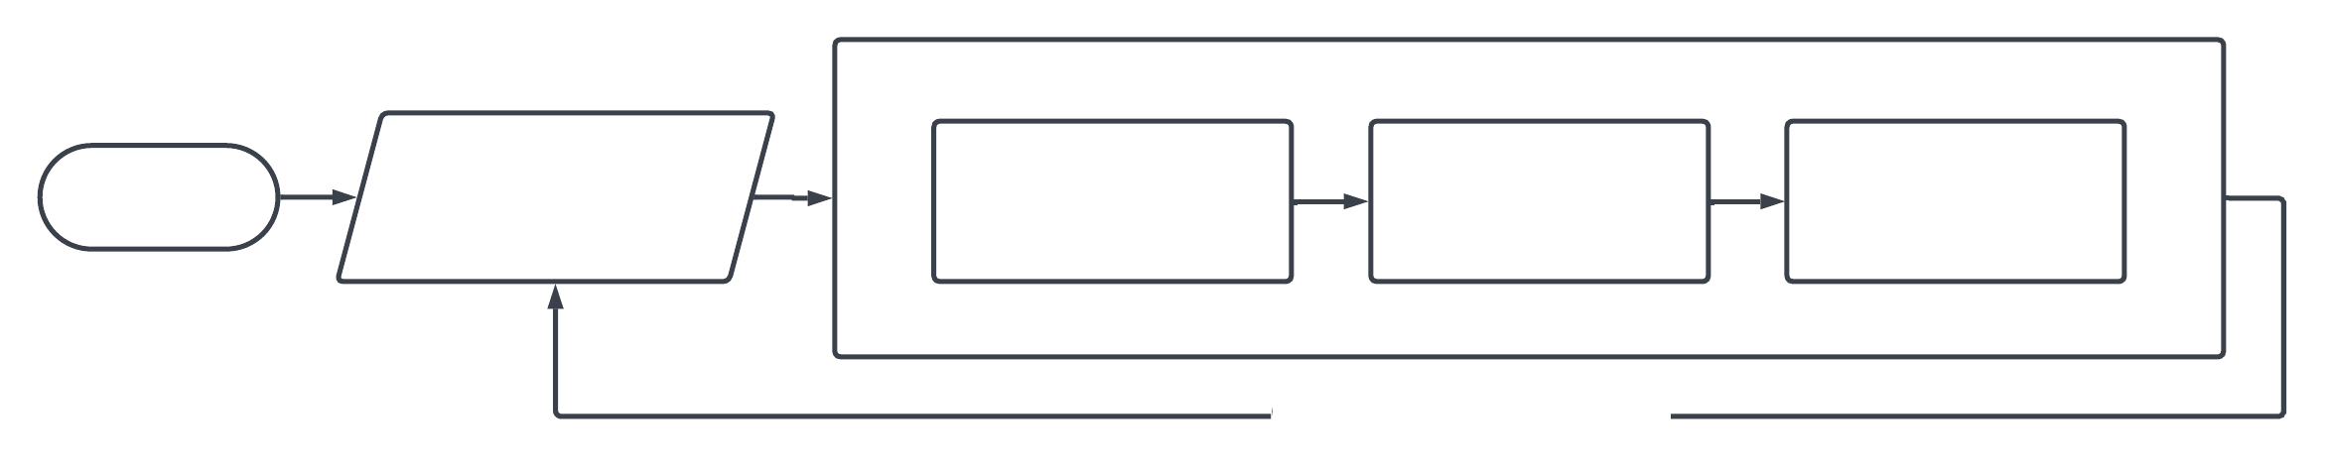
START
LISTEN TO OUTSIDE WORLD DATA WITH SENSORS
UKB MAIN ALGORITHM
FILTERING
DATA PROCESSING
INITIATING A RESCUE OPERATION
FEEDBACK LOOP
Figure 1. FCC Main Algorithm
- Sensor Data Collection: The FCC collects data from different sensors aboard the rocket on such parameters as instantaneous flight altitude (barometric), acceleration, flight direction and inclination, etc., which are then processed in accordance with the FCC’s Main Algorithm.
- Data Processing and Analysis: Flight data received from sensors are continuously analysed by the FCC Main Algorithm, which continuously checks the point reached by the rocket on its flight trajectory (the peak of flight in sounding rockets) and whether the rocket has passed the apogee in its flight.
- Feedback Loop: The sequence defined in the FCC Main Algorithm for the collection of data from the sensors and the analysis of the data is repeated throughout the flight, without interruption, until the launch of the recovery operation.
- Recovery Operation: Once the rocket reaches its apogee and the predetermined conditions have been met regarding the landing trajectory, the recovery system is activated by the FCC, leading to the activation of one or more parachute systems once the necessary conditions are met, and the recovery process is carried out.

Definition of the Rocket Body-Fixed Coordinate System
All acceleration, angle, and attitude data defined within this section are expressed with respect to a Cartesian coordinate system fixed to the rocket body. The coordinate system is defined with reference to the rocket’s centre of mass and is oriented according to the right-hand rule.
X-Axis (Longitudinal Axis):
The origin of the axis is defined at the point where the rocket’s centre of mass coincides with the symmetry axis of the cylindrical rocket body. The positive direction of the x-axis is defined toward the nose of the rocket. The rocket’s roll motion occurs about this axis.
Y-Axis (Lateral Axis):
The origin of the axis is defined at the point where the rocket’s centre of mass coincides with the symmetry axis of the cylindrical rocket body. The positive direction of the y-axis is defined toward the right side of the rocket (when viewed from above with the nose pointing upward). The rocket’s pitch motion occurs about this axis.
Z-Axis (Vertical Axis):
The origin of the axis is defined at the point where the rocket’s centre of mass coincides with the symmetry axis of the cylindrical rocket body. The positive direction of the z-axis is defined toward the ground. The rocket’s yaw motion occurs about this axis.
All data regarding accelerations and angles in x, y and z axes used in the Sensor Monitoring Test (SMT) and Synthetic Flight Test (SFT) scenarios will be interpreted according to this coordinate system definition.
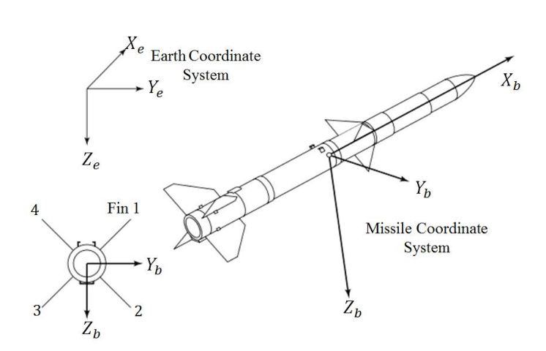
Figure 2. Rocket/Missile and Earth Coordinate Systems

Testing Indigenously Developed FCCs
For the assessment of the mission success of the indigenously developed FCCs (namely ID-FCC) developed by the teams, the ID-FCCs are tested on the ground and under flight conditions under different scenarios that may be encountered during the flight.
A special test device is being developed by the TEKNOFEST Rocket Competition Committee that will be used in the TEKNOFEST Rocket Competition finals at the Aksaray Firing Test Range. The ID-FCCs must pass the field test before being granted flight permission (teams whose ID-FCCs fail to pass the tests will be eliminated from the competition).
The test device monitors the exchange of data between the sensors and ID-FCC via the RS232 communication port. Synthetic flight data for the ground tests that mimic real flight conditions are created by the test system and transmitted to the ID-FCC to test the reliability and performance of the algorithm in the FCC, and to ensure the recovery signals are generated at the required time (triggering the relevant energetic or mechanical subsystem that launches the recovery process).
The evaluation will be carried out under two basic scenarios: a Sensor Monitoring Test (SMT); and a Synthetic Flight Test (SFT);
- Sensor Monitoring Test (SMT): Data received from the ID-FCC’s sensors are transferred to the test device in real time and displayed graphically. Any anomalies or deviations in the data will be identified at this stage. This test will verify the health of the sensor data (free of anomalies), the stability of the data transfer and the ability of the ID-FCC to correctly process data received from the sensors.
- Synthetic Flight Test-SFT: Predetermined environmental data appropriate for the flight profile will be sent to the ID-FCC via the RS232 port, including such parameters as altitude, acceleration and pressure. The ID-FCC is to run its algorithm based on the acceptance of this data as real flight data. The effects of both normal and abnormal data will also be tested in different test scenarios. Under the normal scenario, whether the correct signals are produced by the ID-FCC in accordance with the sent data will be checked, while specially produced erroneous data such as sudden acceleration increases or pressure changes etc. will be transmitted to ID-FCC under the abnormal scenario to test the ability of the ID-FCC to manage errors. This stage assesses whether the device can respond to unexpected situations in an appropriate manner. During the test, the ID-FCC is expected to transmit status packets to indicate its current algorithmic stage.
The test scenarios aim to confirm the ability of the ID-FCC to operate reliably and stably during flight. These scenarios allow a comprehensive evaluation of the accuracy of sensor data, the fault tolerance of the algorithm and the overall performance of the device.
Desktop test software will be provided after the CDR phase allowing the teams to test their devices under the test scenarios and their communication infrastructures in advance. This software will enable teams to verify their communication processes and implement the SMT and SFT scenarios. The teams are expected to be ready for their field assessments, having detected possible errors in advance through the use of this software.

Test Scenarios
The test scenarios will be managed by the tester and all data (input and output) will be tracked. The ID-FCCs must accept the commands given by the test device and detect the test mode and scenario provided by the commands.
ID-FCC should start or stop the SMT or SFT scenarios in accordance with the commands received via the RS232 communication port. When the “Stop” command is received, all test flags should be disabled and the ID-FCC should switch to normal mode. The test device will control the test process by sending start and stop commands to the ID-FCC for the different test scenarios in accordance with the command presented in Table 1. During this process, ID-FCC must constantly listen to the test device and interpret the data.
Function | Header | Command | Checksum | Footer 1 | Footer 2
Start Sensor Monitoring Test (SMT) | 0xAA | 0x20 | 0x8C | 0x0D | 0x0A
Start Synthetic Flight Test (SFT) | 0xAA | 0x22 | 0x8E | 0x0D | 0x0A
Stop | 0xAA | 0x24 | 0x90 | 0x0D | 0x0A
Table 1. Instruction Set Table
Once the start and stop test commands for the SMT and SFT scenarios in Table 1 are applied, the ID-FCC must have the algorithmic structure in Figure 3 to create the data set.
The command set in Table 1 shows the order in which the is sent following each command. These commands are in accordance with the “Big Endian” data transmission notation. Upon the sending of each command, the Header (0xAA) byte is sent first, followed, in order, by the Command, Checksum, Footer 1 (0x0D) and Footer 2 (0x0A) bytes. This procedure is followed to ensure the data are read and processed correctly.

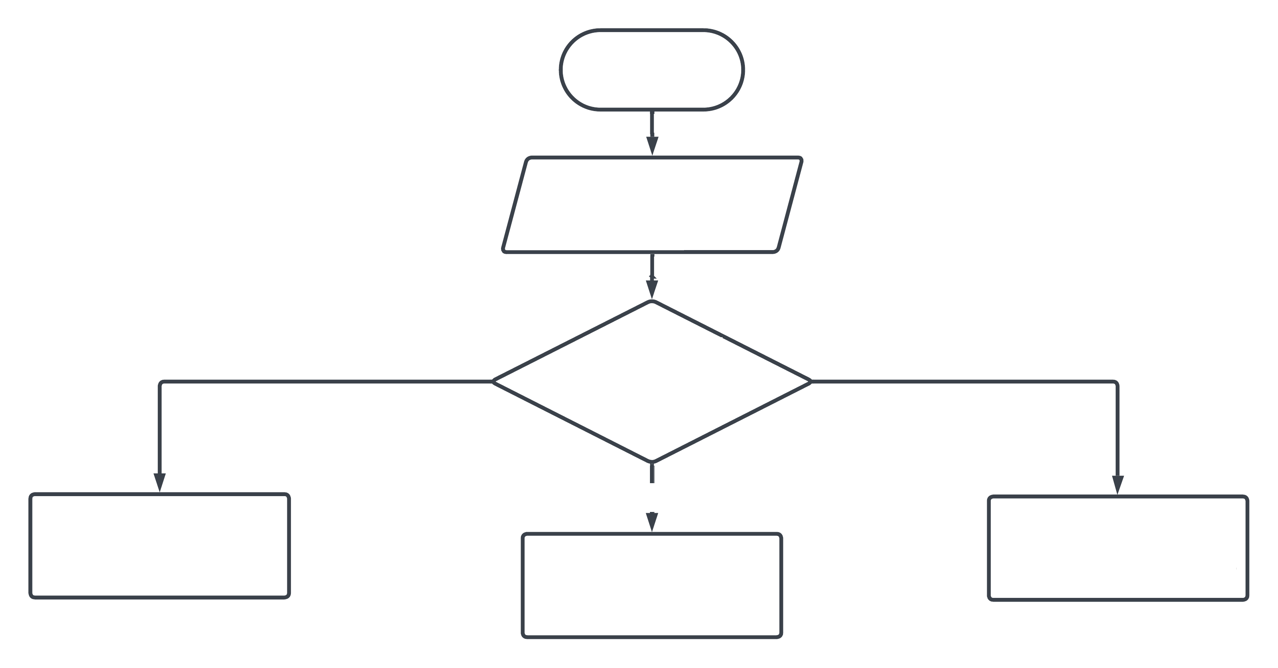
START
LISTEN RS232
SENSOR MONITORING TEST
WHAT IS THE COMMAND FROM RS232?
SYNTHETIC FLIGHT TEST
STOP
ACTIVATE SENSOR MONITORING TEST INITIALISATION FLAG
ACTIVATE SYNTHETIC FLIGHT TEST INITIATION FLAG
DEACTIVATE TEST FLAGS, NORMAL MODAL UKB

Figure 3. Command Decision Diagram

SMT Scenario
If the flag is activated for the SMT scenario, the ID-FCC is expected to operate in accordance with the algorithm structure shown in Figure 4.
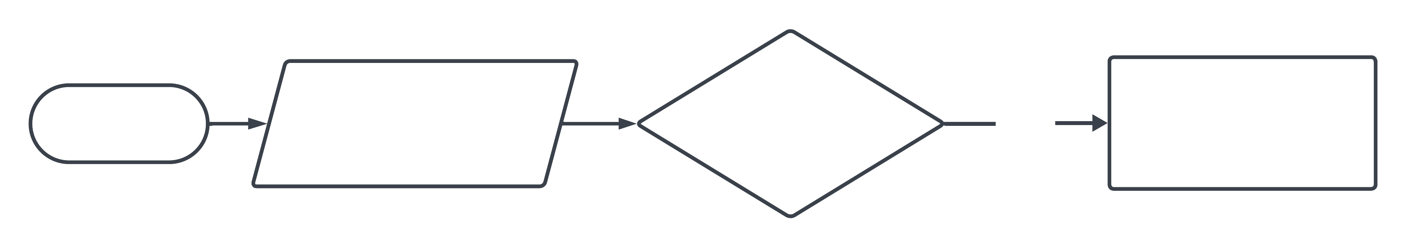
START
LISTEN TO OUTSIDE WORLD DATA WITH SENSORS
IS THE SENSOR MONITORING TEST START FLAG ACTIVATED?
YES
SEND THE DESIRED DATA SET VIA RS232 IN THE APPROPRIATE FORMAT
Figure 4. SMT Algorithmic Scheme
In this scenario, only the transmission of data to the test device is required once the “Start” command arrives. The ID-FCC must read the data provided by the sensors and transmit the data to the test device in the format shown in Table 2. Once the “Stop” command arrives, the test is ended and ID-FCC must stop sending data.
Data Order | Data Type | Unit | Data Type | Data Size | Remarks
Header | Fixed Value | - | BYTE | 1 Byte | Indicates the beginning of the packet
Altitude | Sensor Reading | m | FLOAT | 4 Byte | Shows altitude above sea level
Pressure | Sensor Reading | mBar | FLOAT | 4 Byte | Shows air pressure
Acceleration X | Sensor Reading | m/s² | FLOAT | 4 Byte | Shows acceleration on the x-axis
Acceleration Y | Sensor Reading | m/s² | FLOAT | 4 Byte | Shows acceleration on the y-axis
Acceleration Z | Sensor Reading | m/s² | FLOAT | 4 Byte | Shows acceleration in the Z-axis
Angle X | Sensor Reading | ° | FLOAT | 4 Byte | Shows the angle on the x-axis
Angle Y | Sensor Reading | ° | FLOAT | 4 Byte | Shows the angle on the Y axis
Angle Z | Sensor Reading | ° | FLOAT | 4 Byte | Shows the angle on the Z axis
Checksum | Control Data | - | BYTE | 1 Byte | Checks the accuracy of the data
Footer 1 | Fixed Value | - | BYTE | 1 Byte | Indicates the end of the packet
Footer 2 | Fixed Value | - | BYTE | 1 Byte | The value that completes the end of the packet
Table 2. Telemetry Data Packet Structure
NOTE: The acceleration and angle data presented in Table 2 are defined according to the rocket body-fixed coordinate system described in Section 1.2. All data transmissions to be performed during the test must be carried out based on this coordinate system definition.
The data transmission rate from the ID-FCC to the test device should be set to 10 Hz (10 data per second) (this speed is important for the smooth observation of the data).
The format of all data with “FLOAT” must be limited to 2 decimal places. The tester will only accept data up to 2 decimal places. Table 3 lists the order in which all data should be sent.
Byte 1 | Byte 2 | Byte 3 | Byte 4 | Byte 5
UINT8 | FLOAT32 [0] | FLOAT32 [1] | FLOAT32 [2] | FLOAT32 [3]
0xAB | ALTITUDE 1 | ALTITUDE 2 | ALTITUDE 3 | ALTITUDE 4
Byte 6 | Byte 7 | Byte 8 | Byte 9 | Byte 10
FLOAT32 [0] | FLOAT32 [1] | FLOAT32 [2] | FLOAT32 [3] | FLOAT32 [0]
PRESSURE 1 | PRESSURE 2 | PRESSURE 3 | PRESSURE 4 | ACCELERATION X 1
Byte 11 | Byte 12 | Byte 13 | Byte 14 | Byte 15
FLOAT32 [1] | FLOAT32 [2] | FLOAT32 [3] | FLOAT32 [0] | FLOAT32 [1]
ACCELERATION X 2 | ACCELERATION X 3 | ACCELERATION X 4 | ACCELERATION Y 1 | ACCELERATION Y 2
Byte 16 | Byte 17 | Byte 18 | Byte 19 | Byte 20
FLOAT32 [2] | FLOAT32 [3] | FLOAT32 [0] | FLOAT32 [1] | FLOAT32 [2]
ACCELERATION Y 3 | ACCELERATION Y 4 | ACCELERATION Z 1 | ACCELERATION Z 2 | ACCELERATION Z 3
Byte 21 | Byte 22 | Byte 23 | Byte 24 | Byte 25
FLOAT32 [3] | FLOAT32 [0] | FLOAT32 [1] | FLOAT32 [2] | FLOAT32 [3]
ACCELERATION Z 4 | ANGLE X 1 | ANGLE X 2 | ANGLE X 3 | ANGLE X 4
Byte 26 | Byte 27 | Byte 28 | Byte 29 | Byte 30
FLOAT32 [0] | FLOAT32 [1] | FLOAT32 [2] | FLOAT32 [3] | FLOAT32 [0]
ANGLE Y 1 | ANGLE Y 2 | ANGLE Y 3 | ANGLE Y 4 | ANGLE Z 1
Byte 31 | Byte 32 | Byte 33 | Byte 32 | Byte 33
FLOAT32 [1] | FLOAT32 [2] | FLOAT32 [3] | UINT8 | UINT8
ANGLE Z 2 | ANGLE Z 3 | ANGLE Z 4 | Checksum | 0x0D
Byte 34
UINT8
0x0A
Table 3. Telemetry Package Table

SMT Implementation Plan
- An RS232 connection must be established between the ID-FCC and the test device. The electrical connections of the pyro outputs must be made appropriately for the terminals on the test device. All connections should be made carefully, and checked for strength and accuracy.
- The test device will send the “Start SMT” command defined in Table 1 to the ID-FCC via RS232.
- The ID-FCC must activate the SMT mode one (1) second after detecting the command and confirm the correctness of the command.
- In “SMT” mode, the ID-FCC should start sending the data it receives from the sensors to the test device at 10 Hz (10 data per second). The data sent must be transmitted in accordance with the telemetry packet table defined in Table 3.
- Sensor data from the ID-FCC will be monitored graphically and in real time on the user interface (UI) of the test device. At this stage, the sensor data will be checked for any abnormalities or errors.
- After the test has been run for a sufficient period of time, the “Stop” button will be pressed on the test device and the test device will transmit the “Stop” command in Table 1 to the ID-FCC.
- The ID-FCC should detect the “Stop” command in Table 1 transmitted via the RS232 port, and deactivate all test flags, terminate the test and stop the data transmission.
- The ID-FCC should be ready to return to normal operating mode and start a new testing process.
The purpose of this test is to monitor the live measurement and filtering capabilities of the sensors on the ID-FCC. Irregularities that may arise during flight and that can prevent the rocket from flying safely may thus be detected.
With this test, the presence of data traffic will be ascertained by applying situational changes to the sensors linked to the ID-FCC, for example, by making the ID-FCC experience a sudden movement, inclination or altitude change (maximum 2–3 meters), during which data transfer traffic and data filtering (if filtered, to what level) will be monitored from flight-related sensors.

SFT Scenario
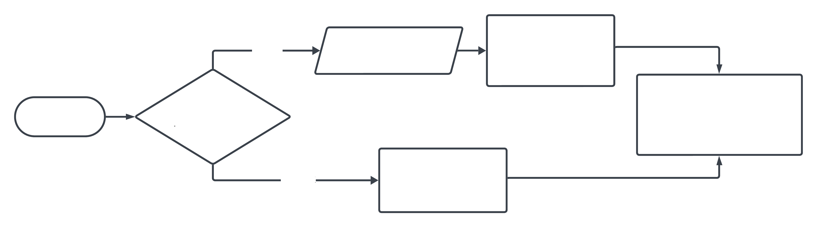
START
SYNTHETIC FLIGHT TEST LAUNCH FLAG ACTIVATED?
YES
NO
LISTEN RS232
ACCEPT INCOMING SYNTHETIC DATA AS SENSOR DATA
CONTINUE READING DATA FROM SENSORS
UKB MAIN ALGORITHM

Figure 5. Synthetic Flight Test Algorithmic Scheme
Once the test device sends the “Start SFT” command to ID-FCC, as in Table 1, the ID-FCC is expected to detect the command and run the basic algorithm shown in Figure 5 to start the SFT. Under this algorithm, once the SFT starts, the ID-FCC is expected to accept the data sent by the test device via RS232 and prioritise it over the data received from its own sensors (which are to be ignored), thus testing the flight algorithm of the ID-FCC with synthetic data generated by the test system.
After starting the SFT, the following synthetic data will be sent from the test device to the ID-FCC:
Byte 1 | Byte 2 | Byte 3 | Byte 4 | Byte 5
UINT8 | FLOAT32 [0] | FLOAT32 [1] | FLOAT32 [2] | FLOAT32 [3]
0xAB | ALTITUDE 1 | ALTITUDE 2 | ALTITUDE 3 | ALTITUDE 4
Byte 6 | Byte 7 | Byte 8 | Byte 9 | Byte 10
FLOAT32 [0] | FLOAT32 [1] | FLOAT32 [2] | FLOAT32 [3] | FLOAT32 [0]
PRESSURE 1 | PRESSURE 2 | PRESSURE 3 | PRESSURE 4 | ACCELERATION X 1
Byte 11 | Byte 12 | Byte 13 | Byte 14 | Byte 15
FLOAT32 [1] | FLOAT32 [2] | FLOAT32 [3] | FLOAT32 [0] | FLOAT32 [1]
ACCELERATION X 2 | ACCELERATION X 3 | ACCELERATION X 4 | ACCELERATION Y 1 | ACCELERATION Y 2
Byte 16 | Byte 17 | Byte 18 | Byte 19 | Byte 20
FLOAT32 [2] | FLOAT32 [3] | FLOAT32 [0] | FLOAT32 [1] | FLOAT32 [2]
ACCELERATION Y 3 | ACCELERATION Y 4 | ACCELERATION Z 1 | ACCELERATION Z 2 | ACCELERATION Z 3
Byte 21 | Byte 22 | Byte 23 | Byte 24 | Byte 25
FLOAT32 [3] | FLOAT32 [0] | FLOAT32 [1] | FLOAT32 [2] | FLOAT32 [3]
ACCELERATION Z 4 | ANGLE X 1 | ANGLE X 2 | ANGLE X 3 | ANGLE X 4
Byte 26 | Byte 27 | Byte 28 | Byte 29 | Byte 30
FLOAT32 [0] | FLOAT32 [1] | FLOAT32 [2] | FLOAT32 [3] | FLOAT32 [0]
ANGLE Y 1 | ANGLE Y 2 | ANGLE Y 3 | ANGLE Y 4 | ANGLE Z 1
Byte 31 | Byte 32 | Byte 33 | Byte 32 | Byte 33
FLOAT32 [1] | FLOAT32 [2] | FLOAT32 [3] | UINT8 | UINT8
ANGLE Z 2 | ANGLE Z 3 | ANGLE Z 4 | Checksum | 0x0D
Byte 34
UINT8
0x0A
Table 4. SFT Telemetry Package Table
NOTE: The acceleration and angle data presented in Table 4 are defined according to the rocket body-fixed coordinate system described in Section 1.2. All data transmissions to be performed during the test must be carried out based on this coordinate system definition.
To speed up the receipt of data by the ID-FCC data and to prevent erroneous data reception, the Header in the command set sent from the test device to ID-FCC will start with "0xAA", and with "0xAB” for synthetic data. The data will be forwarded to the ID-FCC in the order shown in Table 2. The ID-FCC is expected to provide real-time status information about its current flight stage.
An example of the conversion of the “bytes” coming from the test device into a FLOAT32 variable by the ID-FCC is presented under the “Example Communication and Application” heading.
Status Information: This is the data packet that ID-FCC should send only during an SFT. This packet must be transmitted to the test device by the ID-FCC during the test period, and the transmission must be stopped once the test is over. Status bits are the data indicating the flight stage reached in the algorithm reported by the ID-FCC. This packet must consist of two (2) bytes in total, with the following content.
Bit Number | Description / Function
Bit 0 | Rocket launch detected.
Bit 1 | Engine burnout precaution time has expired.
Bit 2 | Minimum …. The meter altitude threshold has been exceeded.
Bit 3 | Rocket body angle is greater than … degrees / horizontal axis acceleration is greater than ….
Bit 4 | The rocket altitude began to decrease.
Bit 5 | The drift parachute deployment command was generated.
Bit 6 | The rocket altitude dropped below the specified altitude.
Bit 7 | The main parachute deployment command was issued.
Bit 8 | Reserved
Bit 9 | Reserved
Bit 10 | Reserved
Bit 11 | Reserved
Bit 12 | Reserved
Bit 13 | Reserved
Bit 14 | Reserved
Bit 15 | Reserved
Table 5. Status Information Table
Table 5 indicates which stage each is allocated for. A bit value of “1” indicates that the system or stage in question is active. A bit value of “0” indicates that the system or stage has not yet been executed and has not been processed algorithmically. During synthetic flight, the main algorithm of the ID-FCC should change the bits at which stage it is and send it to the test device with the specified 2-byte packet structure. The frequency at which status information should be sent should be set to 10 Hz.
While creating this data packet, Table 5 was taken into consideration. The first 8-bit byte of the status packet represents Data 1 within the sent packet, while the second 8 bits represent Data 2.
Header | Data 1 | Data 2 | Checksum | Footer 1 | Footer 2
0xAA | 0x14 | 0x00 | 0x1A | 0x0D | 0x0A
Table 6. Status Information Package Table
The general structure of the status packet should be arranged as shown in Table 6 and the transmission should continue at the appropriate speed until the “Stop” command set in Table 1 is received.
The status information packet in Table 6 defines the data transmission order in accordance with the “Big Endian” notation. Accordingly, when this packet is sent, first the Header (0xAA) byte is sent, followed in order by the Data 1, Data 2, Checksum, Footer 1 (0x0D) and finally Footer 2 (0x0A) bytes. This transmission order is designed to ensure that the data is processed and interpreted correctly by the recipient.

SFT Implementation Plan
- An RS232 connection must be made between the ID-FCC and the test device. The electrical connections of the pyro outputs must be made appropriately for the terminals on the test device. All connections should be checked for strength and accuracy.
- The tester sends the “Start SFT” command defined in Table 1 to the ID-FCC via RS232.
- After the ID-FCC detects the command and confirms its correctness, the SFT mode should activate one (1) second later.
- In SFT mode, the ID-FCC is expected to ignore its own sensor data and accept the data sent by the test device via the RS232 port as the sensor data. This data is then to be subjected to filtering processes and flight algorithms.
- The data to be sent from the test device to the ID-FCC is to be sent in accordance with the format defined in Table 4.
- At the same time, a data package showing the stage reached in the ID-FCC flight algorithm (defined in Table 6) must be transmitted to the test device in a format suitable for Table 5 and at a rate of 10 Hz (10 data per second).
- The data transmitted synthetically to the ID-FCC and the status information data (UI) coming from the ID-FCC is to be monitored graphically in real time from the user interface of the test device.
- After the synthetic flight process is completed, the “Stop” command in Table 1 will be sent to the FCC to terminate the test.
- The ID-FCC should detect the “Stop” command in Table 1 transmitted via the RS232 port, and deactivate all test flags, terminate the test and stop the data transmission.
- The ID-FCC should be ready to return to normal operating mode and start a new testing process.
- The SFT can be administered more than once. Referees may request different synthetic flights using different flight data and different flight profiles under the same scenario to see the reaction of the ID-FCC to abnormal data, if necessary.
The purpose of this test is to verify the ability of the ID-FCC to correctly process synthetic flight data sent from the test device and to run the flight algorithm after disabling data from its own sensors. In such tests, the ID-FCC is expected to activate the recovery system under predetermined conditions and produce separation signals without error. The reliability and fault tolerance of the algorithm under normal and abnormal scenarios will also be evaluated within the scope of this test.
The desired results to be observed during this test are:
- Data Processing: The synthetic flight data from the test device is correctly perceived, processed and incorporated into the flight algorithm by the ID-FCC.
- Flight Algorithm Performance: The ability of the ID-FCC to run the flight algorithm smoothly based on synthetic data, and the algorithm to give the expected responses under different (normal and abnormal) scenarios.
- Recovery System Activation: Under predetermined flight conditions, the ID-FCC must be able to correctly activate the recovery system and, as part of this process, produce the separation signals without error.
- Status Information Package: The ID-FCC is to regularly transmit status information regarding the different flight stages to the test device.
- Error Management: In the event of abnormal data inputs (for example, meaningless acceleration or pressure data), the ID-FCC’s filtering capabilities are to ensure it gives correct responses to unexpected situations.

Testing Requirements
In this section, the requirements that must be taken into consideration in the design of the ID-FCC for the successful implementation of the test scenarios are defined. The teams need to develop appropriate hardware and software that can meet these requirements and be ready for testing processes.

Communication Requirements
The exchange of data between the test device and the ID-FCC will be achieved via the RS232 protocol. The RS232 is a reliable serial communication protocol that ensures the accurate transfer of sensor data and the timely transmission of commands during the testing process. For problem-free communication, the ID-FCC must be configured in accordance with the parameters set out in Table 7;

PARAMETER | REQUIREMENT
Baud Rate | 115200 bps
Parity Bit | None
Data Length | 8 bit
Stop Bits | 1
Communication Mode | Full-Duplex
Table 7. Communication Parameters
These settings are optimized to minimize communication errors during data transfer to ensure the smooth execution of test cases. All communication hardware and software must be configured according to these parameters.
Timing and Flow Strategy
The command processing time (command latency) of the Original Flight Control Computer (O-FCC) test device is specified as ≤ 10 ms. In addition, during the Synthetic Flight Test (SFT) session, the test timeout threshold is defined as 1000 ms (1 second). If this duration is exceeded, the test loop will safely transition to the termination flow.

Hardware Requirements
The ID-FCC hardware must be compatible with the test device to ensure the smooth communication of data. These requirements are vital for the reliability of communication and correct integration of the system with the test device.
The microcontroller to be included in the ID-FCC design must support the RS232 protocol via a software or hardware UART port. The RS232 standard must be converted from the TTL level that is the native output format of the microcontroller. A suitable hardware solution must be used for this conversion.
- Integrated Converter: A reliable converter IC, such as MAX3232, can be used to convert the TTL level in accordance with the RS232 protocol. This integrated circuit will support operation at both 5V and 3.3V logic levels and will provide quick integration and ease of use.
- Alternative Solution: A ready-made module facilitating direct “TTL to RS232” conversion is also available. This module may be a more practical solution to speeding up the integration process.
It must be ensured that the converter or module used is compatible with the test device. During connection, the “Pin” sequences must be configured correctly and electrical stability must be ensured. Electromagnetic interference should not be ignored and the necessary precautions should be taken. At this stage, teams can test the communication of the ID-FCCs they have developed via their computers by using a “USB to RS232” universal converter to ensure correct communication.
Meeting the above hardware requirements in full will ensure that the ID-FCC can communicate with the test device without error, and that the tests can be carried out successfully.
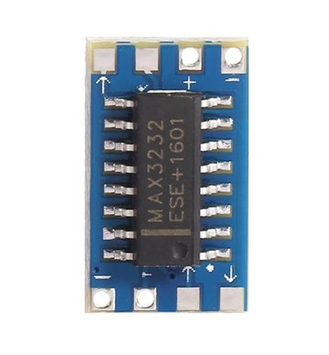
Figure 6. Sample RS232 Converter Module
A basic connection diagram of the ID-FCC designed with the sample RS232 converter card shown in Figure 6 or the MAX3232 converter located on the board should be created as shown in Figure 7.

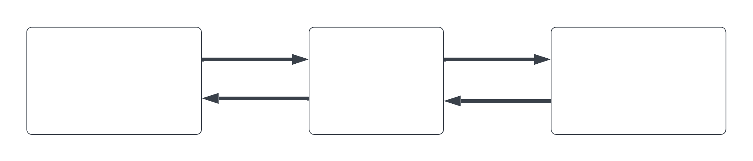
UKB Tester
TX
RX
RS232
MAX3232
RX TX
TX RX
UART
Microcontroller
RX
TX

Figure 7. Basic Wiring Diagram
The MAX3232 integrated circuit can be purchased and integrated appropriately with the ID-FCC. Alternatively, the supply and communication connections to the card can be made and soldered to the ID-FCC via pins or connected with cables using a converter card prepared with the MAX3232 integrated circuit, as in Figure 7.

Electrical Requirements
The ID-FCC must be designed in accordance with certain electrical requirements if it is to work in harmony with the test device. These requirements include the correct configuration of the device’s communication ports and reliable signal connections.
The FCC test device will have a 0-48VDC voltage and 0-10A current measurement capacity. In this context, it is mandatory for the pyro outputs of ID-FCCs to operate within the specified voltage and current limits. In the ID-FCC design and separation system designs, actuators should be preferred so that they do not exceed the specified maximum voltage and current limits. Otherwise, both the safety of the test device and the accuracy of the measurements will be at risk. Therefore, all outputs must be designed in accordance with the relevant limits.
The ID-FCC must have a communication port that can support the RS232 protocol, being the primary port through which data will be exchanged with the test device. It is vital to connect the RX (receiver data), TX (sender data) and GND (ground) lines correctly during communication. The RX and TX pins should be connected crosswise; for example, the RX pin of the ID-FCC should be connected to the TX pin of the tester, and the TX pin should be connected to the RX pin of the tester. The connection model should be prepared as shown in Figure 7. These connections must be meticulously controlled to ensure the uninterrupted and error-free transmission of data.
On the ID-FCC, a D-SUB9 connector or different JST connection should be used with an interconnecting cable that converts to a D-SUB9 connection and should be configured as D-SUB9 female. The test device side is to have a male D-SUB9 connection. Figure 8 shows the male and female pin structures of D-SUB9 connections in detail. Only RXD, TXD and GND pins should be connected during connection. RXD is used for receiving data, TXD for sending data and GND for signal reference. All other pins can be left open.
Recovery signals (Pyro signals) should be transmitted by cables that can be connected to the terminals on the test device. Recovery output cable ends should be opened and placed on the terminals and the connection strength should be checked. This structure will ensure that the recovery signals are transmitted correctly to the test device.
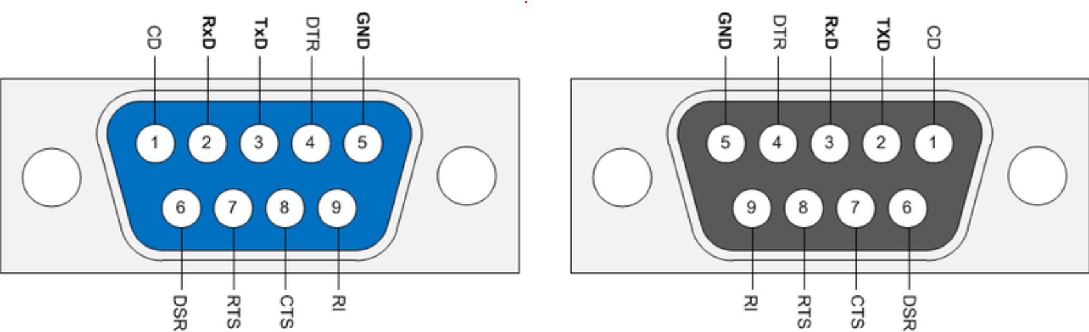
Figure 8. D SUB 9 Ports
The male pin structure is shown on the left, while the female pin structure is shown on the right. The pins given on the electrical requirements list must be connected to the FCC following these pin orders, with an easy connection interface. A male connection is used on the test device.

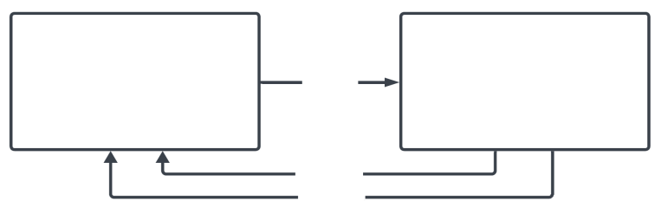
TEST DEVICE
RS232
UKB
PYRO 1
PYRO 2
Figure 9. Test Setup Connection Diagram
The electrical connections between the tester and the ID-FCC are made via RS232, as shown in Figure 9. The “Pyro 1” and “Pyro 2” connections must ensure the transmission of signals associated with the recovery system. Creating a mechanism suitable for this scheme is necessary for the smooth completion of the testing procedures.
Meeting these requirements will ensure the electrical compatibility of the test device and the ID-FCC, and will increase the reliability of data communication.

Checksum and its Calculation
Checksum is a simple error detection method used to ensure the accuracy and integrity of data during data transmission. Checksum is the sum of the values contained within the data, and is checked by the receiving party to verify whether the error-free transmission of data.
Checksum Calculation Steps
- Data Preparation: The data to be calculated is determined as a sequence of bits or bytes.
- Determining the Starting Value: Typically, 0x00 is used as the starting value.
- Collection Process: All the bytes in the data are added together, and the remainder obtained by dividing the sum by 256 (mod 256) is taken.
- Adding Checksum Value to Data: The calculated checksum value is saved in the appropriate location in the data packet to be sent. The receiving party uses this value to verify the sent data.

Sample Communication and Application

Sample Conversion from 4 Byte Array to FLOAT32
Conversion is required to obtain the FLOAT32 variable from the bytes obtained from the test device. This process involves dividing the 4-byte space held by the FLOAT32 type in memory into pieces that are then sent and combined. This process is called “type casting” in the literature. Sample explanations and codes can be accessed through a search for “byte array to float” for the FLOAT32 variable type. Below is a sample C” code for a FLOAT32 conversion:
typedef union{
FLOAT32 sayi_f32;
UINT8 array[4];
} FLOAT32_UINT8_DONUSTURUCU;

void float32_yi_uint8_arraye_donustur(FLOAT32 *sayi)
{
FLOAT32_UINT8_DONUSTURUCU float32_uint8_donusturucu;
float32_uint8_donusturucu.sayi_f32 = *sayi;
UINT8 byte_array_u8[4] = {0};
byte_array_u8[0] = float32_uint8_donusturucu.array[0];
byte_array_u8[1] = float32_uint8_donusturucu.array[1];
byte_array_u8[2] = float32_uint8_donusturucu.array[2];
byte_array_u8[3] = float32_uint8_donusturucu.array[3];
}

Sample Conversion from 4 Byte Array to FLOAT32
A union operation is required to convert the 4-byte data array obtained from the test device into a FLOAT32 variable. This process is based on a reading of the 4 bytes of data in the memory by combining them into FLOAT32 type. In the literature, this method is called “type casting”, and when it is investigated as a “byte array to float” conversion for the FLOAT32 type, various example explanations and codes can be found. Below, a sample “C” code is shared for the conversion of a 4-byte array into a FLOAT32 format:
typedef union {
float sayi_f32;
uint8_t array[4];
} FLOAT32_UINT8_DONUSTURUCU;

float uint8_arrayi_float32_ye_donustur(uint8_t byte_array_u8[4]) {
FLOAT32_UINT8_DONUSTURUCU float32_uint8_donusturucu;
float32_uint8_donusturucu.array[0] = byte_array_u8[0];
float32_uint8_donusturucu.array[1] = byte_array_u8[1];
float32_uint8_donusturucu.array[2] = byte_array_u8[2];
float32_uint8_donusturucu.array[3] = byte_array_u8[3];
return float32_uint8_donusturucu.sayi_f32;
}

